**Python Programming Rookie to Legendary**

**Boot camp.**

**( A complete Python Programming course.)**

**-By Dr. Seema Maitrey**

**Maitrey Educations…**

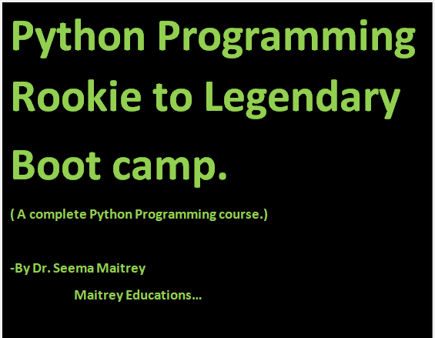

PREFACE-

PYTHON PROGRAMMING ROOKIE TO LEGENDARY is a sincere effort to make Python programming ease rather than fear it. This book contains ample of worksheets for better understanding.

The motive of making this book is to-

* Develop the ability of students.
* Arouse students’ interest and curiosity in Python.
* Nurture students’ intelligent thinking.

Chapter-1: Introduction to Python

* What is python?
* Python is basically an interpreted, general purpose, open source programming language created by Guido Van Rossum in 1991.



* Why should we choose python?
* We should choose python because-

1. It was developed for clear, logical code that is easy to learn.

2. Many existing libraries and frameworks are already made in python that allows users to use python in lots of tasks.

* What really python can do?
* Python can do the following-

1. You can make GUI applications.

2. You can make web sites & applications.

3. You can make window apps (such as- games, etc.)

4. You can also do web scrapping with Python.